***A Community Service Project***

Report on

**Natural Resources and Deforestation**

Submitted to

**JAWAHARLAL NEHRU TECHNOLOGICAL UNIVERSITY ANANTAPUR**

In partial fulfilment of the requirements for the award of the degree of

**Bachelor of Technology**

In

**Electronics and Communication Engineering**

By

**K.HEMALATHA**

**202T1A0426**

Under the esteemed guidance of

Assistant Professor

**Mr. Syed Noorullah**

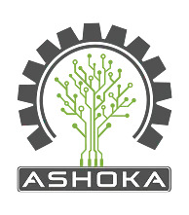

**DEPARTMENT OF ELECTRONICS AND COMMUNICATION ENGINEERING**

**ASHOKA WOMEN'S ENGINEERING COLLEGE**

**OPP. DUPADU (RS), NH-44, LAKSHMIPURAM (PO), KURNOOL-518218**

**2022-2023**